CSCI 2270: Data Structures Final Project

Nathan Straub and Pourna Sengupta

April 28, 2020

Of the three structures, Linked List, Binary Search Tree, and Hash Table, it was found that the Binary Search Tree performed the fastest. In all cases, the structures took longer to insert the first hundred data points rather than search for the given hundred points. The Hash Table ran faster than the Linked List, making the Linked List the slowest structure out of the three. The run times for indices 1-400 were measured and averaged. The data was then plotted in the graphs below. These graphs show that the insert functions in each structure took longer to run than the search function.

Data Set

Data Set

Linked List

Linked List

**

Binary Search Tree

Binary Search Tree

Linear Hash Table

Quadratic

Chain Hash Table 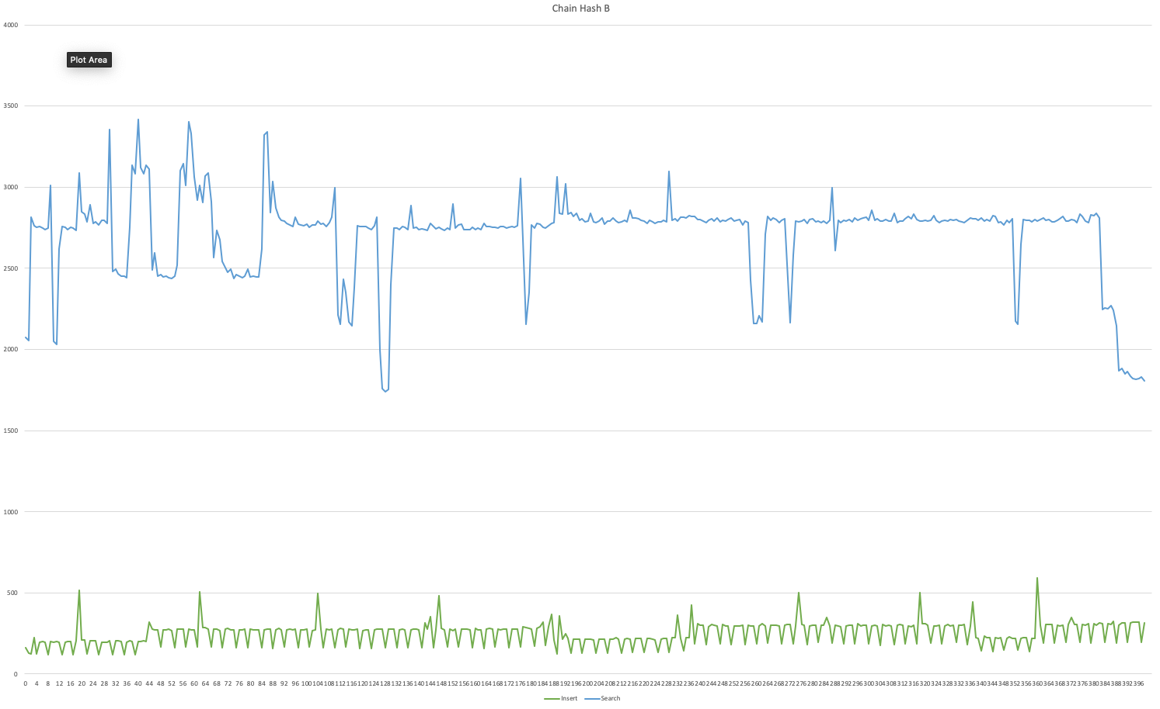

Chain Hash Table